Template for Preparing an Article

Author One1, Author Two2, Author Three3*

1 Organization Name, Department Name, City, State, Country

2 Organization Name, Department Name, City, State, Country

3 Organization Name, Department Name, City, State, Country

*\*Corresponding author: institution; addresses; author3@email*

Received Month, Year X, XXXX; revised Month X, XXXX; accepted Month, Year X, XXXX

**Abstract** This document gives formatting instructions for authors preparing papers for publication in the journal. Authors are encouraged to prepare manuscripts directly using this template. This template demonstrates format requirements for the Journal.

**Keywords:** Format, Microsoft Word Template, Style, Insert, Template.

**Abbreviations**: Format, Microsoft Word Template, Style, Insert, Template.

To use this template, you will need to (1) apply the embedded styles to each paragraph-level item in your manuscript or (2) use the specifications shown in Table 1 to format your manuscript, with this template as a visual guide. Information about paper submission is available from the Journal website.

Table 1. Font Sizes for Papers.

|  |  |  |  |  |
| --- | --- | --- | --- | --- |
| Font Size | Appearance (in Time New Roman) | | | |
| Regular | Bold | Italic | Underline |
| 10 | Author affiliation  Abreviations of tables, figures, box;  References | Author name  Abstract body  Keywords,  Abreviations of the text | Corresponding author  Received Line |  |
| 12 | Main text,  Description of figures, tables box and graphics  Section headlines – level 2 | Section headlines – level 1 | Section headlines – level 3 | Section headlines – level 2 |

2. Ease of Use

An easy way to comply with the journal paper formatting requirements is to use this document as a template and simply type your text into it.

The template is used to format your paper and style the text. All margins, column widths, line spaces, and text fonts are prescribed; please do not alter them. Your paper is one part of the entire proceedings, not an independent document. Please do not revise any of the current designations.

2.1. Page Layout

Your paper must use a page size corresponding to A4 which is 210mm wide and 297mm long. The margins are set as follows: top= 15 mm, bottom= 15 mm, right=17.5 mm, left = 20 mm. Your paper must be in two column format with a space of 1.93 characters between columns.

2.1.1. Front Matter

The title should be formatted in an hourglass style; the first line longer than the second, the second line shorter than the third. Use numerical superscript callouts as shown in this template to link authors with their affiliations.

Corresponding author should be denoted with an asterisk as shown. E-mail address is compulsory for the corresponding author.

2.1.2. Text Font

The mais text should be in Times New Roman font size 12. Paper title must be centered, bold, regular font size 12. Author names must be centered, bold, regular font size 10. Author affiliation must be regular font size 10. Email address must be centered, italic, font size 10. Recommended font sizes are shown in Table 1. No more than 3 levels of headings should be used. Level 1 heading must be left-justified, bold, regular font size 12 and numbered using Arabic numerals. Level 2 headings must be left-justified, regular, underline, regular font size 12 and numbered as subheading (i.e 1.1). Level 3 heading must be left-justified, italic font size 10 and numbered as sub-sub heading (i.e 1.1.1) and the first letter of each word capitalized.

2.1.3. Equations

Display equations should be broken and aligned for two-column display unless spanning across two columns is essential. Equations should be centered with equation numbers set flush right. If using MathType, use the Format Equations feature to format all equations as Times + Symbol 10.

 (1)

2.1.4. Tables

Styles for table title, table head, and table text are provided. Tables should be set in one column wherever possible and be placed near their first mention in the body. Tables, figures and graphics need to be placed on separate pages at the back of the manuscript.

2.1.5. Figures

As with tables and equations, figures should be set in one column if possible unless two-column display is essential. The resolution of image should be adequate to reveal the important detail in the figure (300 dpi).

2.1.6. Figure Captions

Figure captions should be below the figures. Figures must be numbered using Arabic numerals. Figure captions must be in 10 pt regular font. Captions of a single line (e.g. Figure. 2) must be left-justiied whereas multi-line captions must be justified (e.g. Figure. 1). Captions with figure numbers must be placed after their associated figures, as shown in Fig. 1.

Figure 1. (Color online) Forward single pass experimental set-up for evaluating EDFA performance.

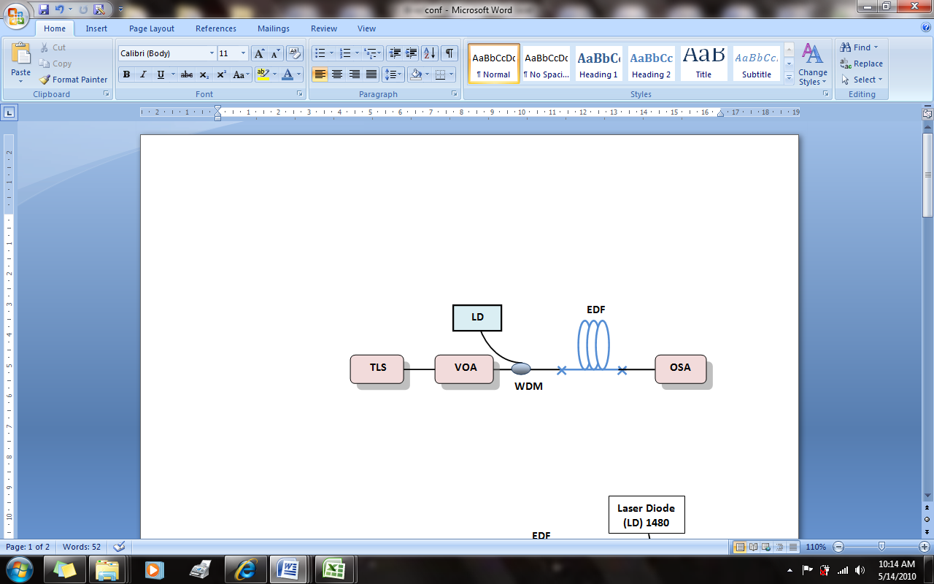

**Figure 2.** Biochip Reader integrated circuit (details).



Graphic 1. Diagram example



2.1.7. Table Captions

Table heads should appear above the tables. Tables must be numbered using Arabic numerals. Table captions must be left-justified and in 12 pt Regular font. Captions with table numbers must be placed before their associated tables, as shown in Table 1.

3. References Formats

The heading of the References section must not be numbered. All reference items must be in 10 pt font. Number the reference items consecutively in square brackets (e.g. [1]). When referring to a reference item, please simply use the reference number, as in [2]. Do not use “Ref. [3]” or “Reference [3]” except at the beginning of a sentence, e.g. “Reference [3] shows …”. Multiple references are each numbered with separate brackets (e.g. [1], [2]–[3]).

A complete reference should contain the name(s) of the author(s) and/or editor(s), the title of the article, the name of the book or conference proceedings where appropriate, and bibliographic information about the article such as the name of the publisher, the city of publication, and the page numbers. The basic concept is that the reference should be sufficiently complete so that the reader could readily find the reference and can judge the authority and objectivity of the reference.

Books

Standard format

Authors, Title (regular), Publisher, City of Publication, Year of Publication, page numbers(if appropriate).

Example:

1. Fogg, B.J, Persuasive technology: using computers to change what we think and do, Morgan Kaufmann Publishers, Boston, 2003, 30-35.

Journal articles

Standard format

Authors, "Title of the article," Journal name(regular), Yera, Volume (Issue), Month, Pages.

Example:

Hirsh H., Coen MH., Mozer, MC, Hasha R., Flanagan, JL. Room service, AI-style. IEEE intelligent systems, 2002;14 (Jul 2):8-19.

Conference Proceedings

Standard format

Authors, "Title of the article," in Title of conference (regular), Publisher, Pages.

Example

Leclercq, P. and Heylighen, A. 5,8 Analogies per hour: A designer's view on analogical reasoning, in 7th International Conference on Artificial Intelligence in Design, Kluwer Academic Publishers, 2016:285-303.

E-Books

Standard format

Authors, Title of E-book (regular),Publisher, Date of original publication. [Format] Available: Source.

Example

T. Eckes, The Developmental Social Psychology of Gender, Lawrence Erlbaum, 2000. [E-book] Available: netLibrary e-book.

E-journal

Standard format

Authors, Title of Article,Title of Journal (regular), Year, Volume (Issue), month, pages. [Format]. Available: Database Name (if appropriate), article number (if given),

internet address. [Accessed date of access].

Example

Steiner A., Understanding hypertext in the context of reading on the web: Language learners' experience. Current Issues in Education, 2013;6(July12):2015-219. [Online].

Available: http://cie.ed.asu.edu/volume6/number12/.[Accessed Dec. 2, 2013].

Acknowledgement

The heading of the Acknowledgment section and the References section must not be numbered.

References

1. Fogg, B.J, *Persuasive technology: using computers to change what we think and do*, Morgan Kaufmann Publishers, Boston, 2003, 30-35.
2. Hirsh, H., Coen, M.H., Mozer, M.C., Hasha, R. and Flanagan, J.L, “Room service, AI-style,” *IEEE intelligent systems*, 14 (2). 8-19. Jul.2002.
3. T. Eckes, *The Developmental Social Psychology of Gender*, Lawrence Erlbaum, 2000. [E-book] Available: netLibrary e-book.